
On the 7th of April, an industry visit to PPG was held. Although several industry talks had previously been delivered by PPG, this visit was more meaningful because it was the first opportunity to visit the company’s office and working environment physically. The journey started early in the morning, as the students departed at around 5.00 a.m. Upon arrival, the visit began with an industry sharing session, where PPG was introduced again to provide a clearer understanding of the company background and its business operations.
PPG was introduced as a global company that focuses on paints, coatings and specialty materials. Its products are used in various industries such as automotive, construction, industrial and consumer markets. It was understood that PPG is not only involved in manufacturing but also depends on technology, data and business systems to support its global operations.
During the session, the departments that were closely related to the Data Engineering field were introduced, especially the Data Engineering department and SAP Operations. The Data Engineering department was explained through PPG’s data lake architecture, where data from different sources such as Oracle, SAP, business applications, files and logs is collected and processed. The data pipeline was shown to follow several layers, including Bronze, Silver, Gold and Curated layers. From this explanation, it was learned that raw data must be ingested, cleaned, transformed and prepared before it can be used for reporting, dashboard development and business decision-making. Tools such as Azure Data Factory, Azure Databricks, Delta Lake, Python, SQL and Power BI were also introduced.
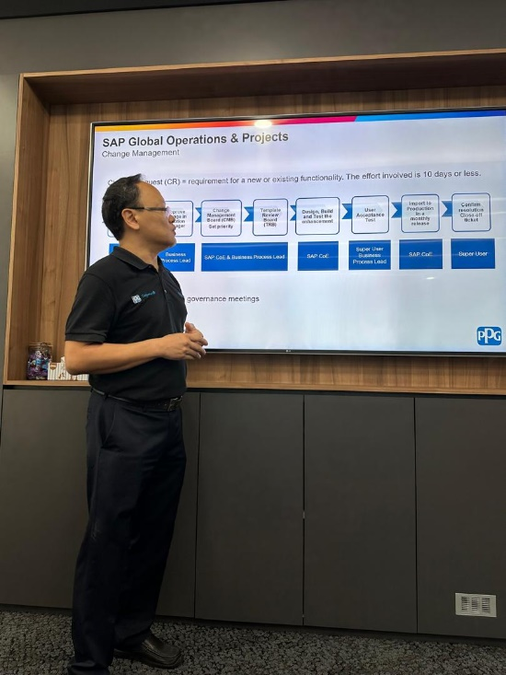
SAP Operations was also explained as an important department that supports business processes and system changes in PPG. It was learned that every change request must go through a proper change management process including review, design, testing, user acceptance testing, production release and ticket closure. This showed that system changes in a company must be carefully controlled to ensure accuracy and smooth operations.
After the sharing session, we were brought around the office to have a visit. This gave a better picture of a their working environment. The internship programme was then introduced, including the job scopes, flexible working schedules and the entertainment.
The final session focused on the project case study related to inventory management. PPG’s business problem involved slow-moving and excess inventory which could lead to financial risk, storage costs and inaccurate financial reporting. The concepts of Recoverable Assets (RA) and Magna Carta (MC) were introduced. The project objective was to build an automated data-driven solution to identify excess inventory, flag write-down candidates, calculate financial impact, detect stockout risks and support decision-making.
Overall, this industry visit was a valuable experience because it connected classroom learning with real industry practices. A clearer understanding of data engineering, SAP operations and business problem-solving was gained. The visit also showed that data engineering is not only about technical skills but also about understanding business needs and creating useful solutions for decision-making.

